**Assignment 21.2**

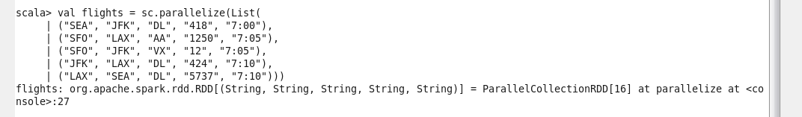

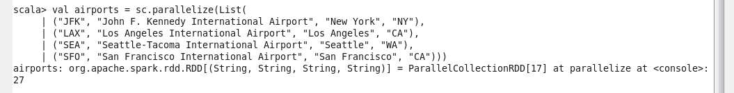

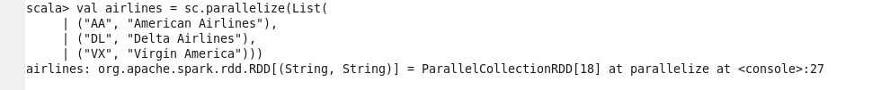





Materializing the airports data



